Report on Consultation and Statement of Regulatory Assessment regarding the proposal by Oxford City Council to update its Byelaws for Parks and Open Spaces
Contents
Background 2
Consultation methodology 2
Results 3
Overview of key findings 3
Conclusions 5
Recommendations 6
Regulatory Assessment 6
Appendices 8
Appendix 1: How strongly respondents agree or disagree with the proposed byelaws 8
Appendix 2: Impact of the proposed byelaws on respondents 28
Appendix 3: Oxford City Council launches public consultation on proposed changes to parks and open spaces byelaws 39
Appendix 4: Stakeholders contacted 41
Appendix 5: Sample comments relating to the main areas of concern and topics for suggested amendments 45

Background
Oxford City Council (“the Council”) has a set of byelaws in place for its parks, nature areas and play facilities which provide a basic set of rules around the use of these public spaces to ensure people behave in way which respects the enjoyment, wellbeing and safety of others. They are also aimed to ensure the protection of habitats, wildlife and the wider environment. These byelaws have been in place for nearly 30 years and the Council now proposes to update them so as to:
- Revoke old byelaws no longer relevant/appropriate and which conflict with the desire to promote healthier lifestyles
- Ensure that the proposed byelaws deal with new challenges and changing priorities
- Update the list of sites currently covered to address previous omissions and naming errors to ensure consistency, to include new play spaces created since the byelaws were last updated and to remove other sites which have been or are planned to be subject to change of land use
- For simplification and consistency, apply to revoke the separate set of byelaws for Shotover Country Park and include the site under the main park byelaws
The Byelaws (Alternative Procedure) (England) Regulations 2016 (“the 2016 Regulations”) introduce new arrangements for byelaws. The proposed byelaws are being made in accordance with the procedure specified in the 2016 Regulations. The Council must undertake a regulatory assessment of the proposed byelaws to ensure they are proportionate. When carrying out the regulatory assessment the Council must consult those affected by the proposed byelaws. It is also the Council’s policy to engage with stakeholders on matters which may impact them.
The proposed byelaws are being made under section 164 of the Public Health Act 1875, sections 12 and 15 of the Open Spaces Act 1906 and Section 235 of the Local Government Act 1972 by the Council with respect to the public spaces listed in Schedules 1 – 4 of the proposed byelaws with respect to pleasure grounds, public walks and open spaces, for the good rule and government of Oxford City Council and for the prevention and suppression of nuisances.
This report describes the methodology for the consultation undertaken as part of the regulatory assessment and the results of the feedback. Graphs representing the support for and the impact of the proposed byelaws are to be found in Appendices 1 and 2 respectively. Conclusions are provided on the results, and a set of recommendations based on the public feedback. The report also comprises the statement of the regulatory assessment.

Consultation methodology
A draft of the proposed byelaws were prepared, based on the model byelaws (with some adjustments), following the Secretary of State’s guidance notes accompanying the model byelaws, and best practice to provide a framework for the consultation, accompanied by an updated list of sites to which the proposed byelaws would be applied (Schedules) and a link to a digital map showing the sites.
The consultation consisted of a widely publicised, open-to-all, online questionnaire, combined with a proactive approach to an extensive range of stakeholders for the Council’s green spaces. This included specific groups, such as cyclists and disabled people, in accordance with government guidance. Appendix 4 contains a list of all the stakeholders contacted.
The consultation ran from the 12th of February to the 8th of April 2024. It was made available through the Council’s online consultation portal. The link was shared on the Council’s social media platforms, as well as in a press release. Appendix 3 contains the press release.
The stakeholders contacted were encouraged to take part in the questionnaire, offered a question and response service via email or phone to make enquiries to request additional information or provide comments. There was also an offer for face-to-face workshops should any group desire them.
Respondents to the questionnaire were able to just give approval or state disapproval for the overall set of byelaws, or approve/disapprove individual byelaws, and also make comments and suggestions on each one, should they wish.

Results
The total number of responses to the online survey was 523. This included responses from 20 people who were not resident in the Council’s area. In addition to responses in support or opposition to the proposed byelaws, many of the respondents also provided comments. Some of the stakeholder groups engaged, and a small number of individuals, chose to provide comments separately from the online survey via email/letter. There was no take-up on the offer for workshops, but several stakeholders did contact the Council to request additional information or seek clarifications before completing the online questionnaire.
In addition to analysis of the quantifiable number of responses in support or opposition presented in the graphs below (Appendices 1 and 2), all of the comments submitted on the online survey, and those provided separately, were reviewed to identify general feedback themes, concerns and suggestions.
Although there was a good overall age range of respondents, typically with such consultations, and despite direct approaches to relevant stakeholder groups, there was an under representation of young people. However, some balance is provided by the proactive consideration of their needs through the proposal to revoke old byelaws relating to ball games and tree climbing, and their likely support to lift the blanket ban on cycling in parks.

Overview of key findings
- A majority (60%) of the respondents were supportive of the proposed updated byelaws in general
- A majority, and in most cases significant majority, supported each of the individual updated byelaws proposed
- A majority supported lifting the blanket ban on cycling in parks, but a strong desire was expressed for it to be retained for Hinksey Park (other than use of the designated cycle track), and at the Trap Grounds and Lye Valley nature areas
- A significant majority of respondents did not feel they would be unduly impacted by the proposed byelaws other than in relation to cycling in parks (though this reflects consideration of both positive and negative impacts: the views of cyclists who would be negatively impacted by the retention of the blanket ban on cycling in parks and positively by the lifting of the ban; and the views of those who think there could be a potentially negative impact on pedestrians by lifting the ban)
- There was a significant majority in favour of revoking the old byelaws regarding ball games, tree climbing and wild swimming
- Although there were a number of comments in support of retaining a separate set of byelaws for Shotover Country Park, a majority supported the proposal to revoke the existing set and include the site under the general park byelaws

Although the results evidence clear overall support for the draft proposed byelaws, there were also many comments raising concern on various issues, and suggestions on how the draft proposed byelaws could be improved. A sample selection of comments relating to the main areas of concern and suggested amendments is provided as Appendix 5. As expected, the most contentious issue amongst respondents was the proposal to lift the blanket ban on cycling in parks. Despite majority support to lift the ban, many respondents were concerned whether a balance of considerate cycling could be achieved, and even amongst the many who supported lifting the blanket ban, there were many comments requesting a retention of the ban at Hinksey Park (other than the use of the designated cycle path through the outer park), and Trap Grounds and Lye Valley wetland nature areas due to the localised risks of narrow paths, blind bends and fragile boardwalks etc.
A number of respondents raised concerns about the proposed byelaw relating to teenagers using play areas set aside for younger children. Although there were concerns of misuse of play areas and equipment which can be off-putting to younger children and parents, it was highlighted that some teens continue to enjoy play equipment (particularly swings) and questioned how this would be enforced when teens do not generally carry ID stating their age. Rather than have a specific byelaw stating an arbitrary age for use of play areas, it was suggested this issue could instead be policed through the proposed general byelaw 31 (c), relating to causing obstruction or annoyance to others.
Regarding proposed byelaw 31 (c) in general, there were several comments requesting that the wording should include reference to endangerment as well as annoyance to others.
Another common request was for proposed Byelaw 6 relating to fires to specifically reference the prohibition of barbecues.
Some interest groups and individuals made comments objecting to the proposed byelaws relating to their particular pastimes, but the majority of respondents wanted to see activities regulated to avoid impacts on other parks users. Despite the wording within the proposed draft byelaws specifically stating that many of the activities listed will not be in breach of the byelaws where they are authorised by the Council, a number of respondents’ comments suggested some confusion on this. In general, the byelaws allow regulation of activities so they can be enjoyed safely in public spaces without impacting on others. Only certain activities would be prohibited where they pose an obvious risk, but even the majority of these can be enjoyed in areas specifically set aside for that purpose, or carefully managed as part of an organised event or club. Regulation and licensing of events and organised activities in public spaces also allows appropriate risk assessment, safeguarding, and insurance checks to be undertaken. Many of the comments and overall level of support evidenced a broader understanding of these motivations to ensure regulation of certain activities.
A number of comments suggested a misunderstanding by some respondents around the motivation to revoke the old byelaws relating to ball games, tree climbing and wild swimming. Although there is a consideration they are in conflict with the need to encourage more active lifestyles, the primary reason to revoke them is that the threat of court action is simply an inappropriate response to deal with a child or young person climbing a tree or playing a ball game where it is causing a temporary annoyance. Similarly, the Council will continue to advise against wild swimming on its land due to the well-publicised water quality risks and other dangers. However, there would appear to be no value or viability to take legal action against those who choose to do this despite the known risks, and there is no public support to take such action. This was confirmed by the responses received to the consultation.
Despite the list of sites to which the byelaws would apply being provided as part of the consultation, and a link to a digital map showing these sites, comments and suggestions by a number of stakeholders revealed they had not understood the proposed byelaws would, and could only be, applied to sites and facilities owned by the Council. This included a number of respondent comments assuming the proposed byelaws could be used to tackle water pollution created by water companies where the source of that pollution was offsite. This would not be the case and there are already numerous regulatory powers covering this issue.

Conclusions
A wide range of stakeholders were contacted and encouraged to take part in the consultation regarding the proposed byelaws for the Council’s parks and open spaces. Over 500 people responded to the questionnaire, and others sent comments and recommendations separately. This provides a significant measure of feedback and is comparable, if not greater, to that received through the Council’s recent broader residents’ survey for which there was 509 respondents.
The consultation results provide clear support for the proposed draft byelaws, both in general and for each of the individual proposed byelaws. The higher level of support for the majority of the individual proposed byelaws compared to the overall approval rating would appear to reflect concerns over particular issues and the wish to suggest some amendments. There was also a significant majority in support of the proposal to revoke old byelaws relating to ball games, tree climbing and wild swimming, and to revoke the old Shotover Country Park byelaws and to include the site under the general park byelaws.
Although many people raised concerns about the proposal to remove the blanket ban on cycling in parks, the majority support suggests, on balance, most people consider the benefits outweigh the negatives. However, even amongst many who supported removing the blanket, there was a strong desire expressed that the ban should be retained for Hinksey Park, and at the Trap Grounds and Lye Valley nature areas. Even if supported, a general ban on cycling in parks is difficult to enforce given the large number and scale of the green spaces owned and managed by the Council, but a risk-based prohibition in certain locations would be an appropriate and reasonable proposal in response to the concerns raised. This can be achieved by including a byelaw within the new updated version prohibiting cycling which only applies to a specified number of named sites (separate Schedule).
Despite general support for the proposed byelaw relating to teenagers using play areas, the observation made by several of the respondents regarding the appropriateness and difficulty in enforcing it is pertinent, and any clear misuse of play areas could be dealt with through use of proposed byelaw 31 (c) relating to causing obstruction or annoyance to others.
Although a significant majority of respondents did not feel they would be unduly impacted by the application of the proposed byelaws, comments by some suggested concern about the increase in regulation and how the proposed byelaws would be enforced. This issue is addressed later in this report.

Recommendations
The draft proposed byelaws should be adopted, following the thorough consultation. The following recommendations are made based on the consultation responses:
- The blanket ban on cycling in parks should be lifted, but retained at Hinksey Park, Trap Grounds (Local Wildlife Site) and Lye Valley (Site of Special Scientific Interest) by means of a separate schedule allowing a byelaw to only apply to these specified sites;
- The legal definition of an e-bike under UK law to be added to the byelaws to ensure there is a clear distinction between these and motorbikes of any description;
- Proposed byelaw 14 relating to use of children’s play equipment should be removed;
- The wording of proposed byelaw 6 relating to fires should include specific reference to barbecues;
- The wording of proposed byelaw 31(c) should include reference to endangerment in addition to annoyance;
- The old byelaws relating to ball games, tree climbing and wild swimming should be revoked; and
- The separate old set of byelaws for Shotover Country Park should be revoked and the site included in the main updated park byelaws.

Regulatory Assessment
The objectives of the proposed byelaws are set out above. The Council has considered whether the objectives of the proposed byelaws could be achieved in any other way, short of a byelaw. It concludes that the absence of the proposed byelaws would negatively impact those affected in that:

- There would be no clear, central point of reference for the public regarding what they can and can’t do in the Council’s green spaces
- This would greatly reduce the powers available to officers to tackle antisocial behaviour which can impact on the safety of the public and protection of habitats
- Dealing with vehicle trespass would subsequently rely on reference to the courts on a case-by-case basis with the delays around eviction and significant costs implications
- Public Space Protection Orders could be introduced to tackle certain forms of antisocial behaviour, but these require evidence of serious and ongoing issues at a specified location and have to be renewed every three years, with the resource and costs implication involved. Notwithstanding that a Public Spaces Protection Order could fulfil some of the purposes of and need for the proposed byelaws, the Council believes, for the reasons set out in this report, that there is a continuing need for the proposed byelaws.
The Council has consulted with those potentially affected by the proposed byelaws, including persons who are not local residents. In addition to providing clear support for the proposed byelaws (with amendments), a significant majority of respondents did not feel they would be unduly impacted by the adoption of the proposed byelaws.
The proposed byelaws will not increase the regulatory burden imposed upon those affected by it. The changes proposed would merely reinforce what were existing set of byelaws, and although some new byelaws have been added, others would be revoked. The existing blanket ban on cycling currently provides the greatest challenge to enforce due to the large number of parks covered and staff required to enforce them. The byelaws proposed to be revoked connected to climbing, ball games and wild swimming are also more contentious and difficult to enforce, and therefore more open to legal and other challenges.

A larger number of sites are included in the schedule of sites to be covered under the proposed byelaws, but this reflects a more comprehensive and accurate list of the public green spaces owned by the Council than that provided under the existing byelaws. The historic, random omission of a number of sites under the existing byelaws has created confusion, and the potential for indirect discrimination resulting in different regulations being in force at different Council-owned green spaces in different parts of the city. Overall, having a more comprehensive, relevant and enforceable set of byelaws should better support officers in their role to ensure the Council’s parks and nature areas remain safe spaces for all their users. Having a set of more relevant byelaws and comprehensive list of sites covered should also lead to less confusion amongst the public and less enquiries and challenges.

Steps have been taken to ensure the proposed byelaws would be more proportionate than the existing byelaws by focusing on addressing behaviours which have the potential to cause harm or distress to others, or damage to park and waterway infrastructure, wildlife habitats or the wider environment. Existing byelaws which the Council considered to be disproportionate and inappropriate, such as those connected to tree climbing, ball games and wild swimming would be revoked.

The enforcement of the byelaws very rarely results in progressing to court action and there is no desire to see this change. The proposed byelaws are designed to provide a clear set of rules around the use of the Council’s many public green spaces for the protection of all users, parks and waterways infrastructure and ecology. In a vast majority of cases, verbal and written warnings and notices highlighting the existence of the byelaws and potential legal action against those in breach of them is sufficient action. Having a more focused and comprehensive set of byelaws available on the website is also aimed to reduce confusion and proactively advise which activities are or are not permitted to avoid breaches occurring in the first place.

Appendices

Appendix 1: How strongly respondents agree or disagree with the proposed byelaws

Graph 1: Do you support the current byelaw proposal in general?
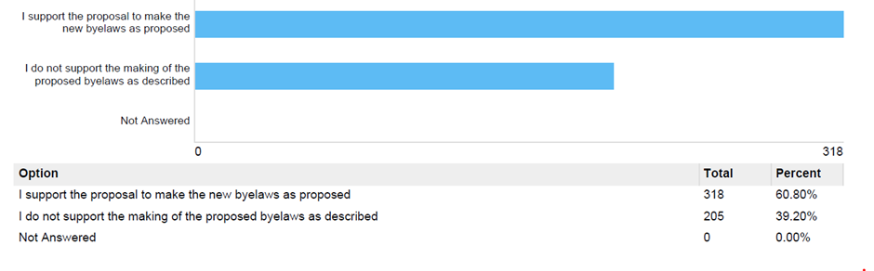

Graph 2: How strongly do you agree or disagree with revoking the existing byelaws relating to a general ban on cycling?
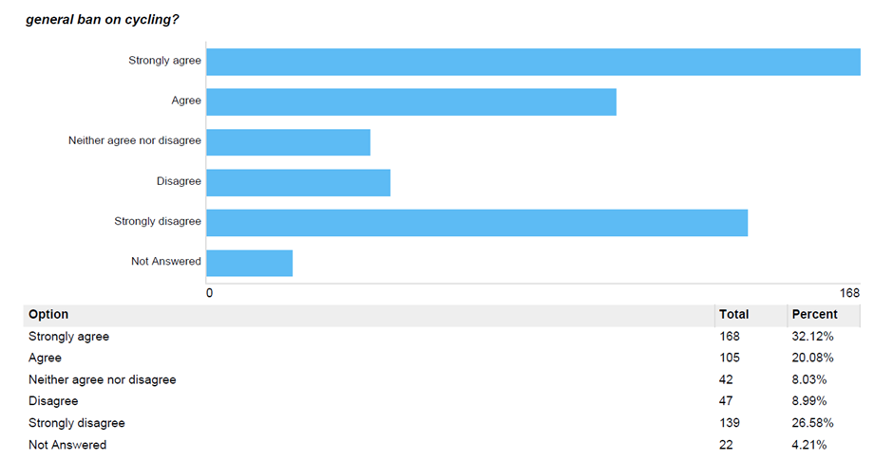

Graph 3: How strongly do you agree or disagree with revoking the byelaws relating to ball games and climbing?
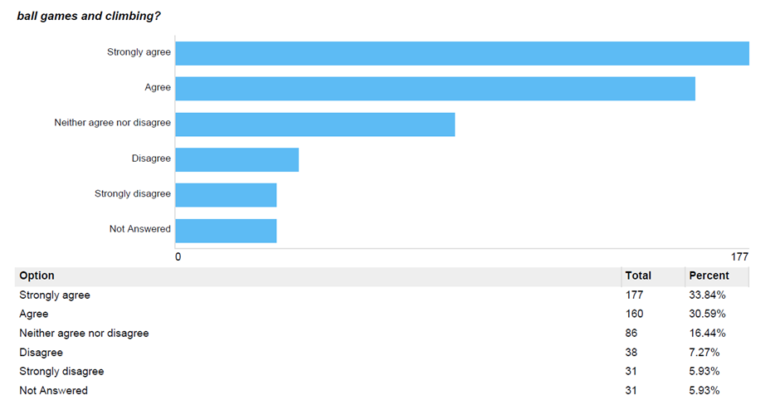

Graph 4: How strongly do you agree or disagree with revoking the byelaws relating to open water bathing?
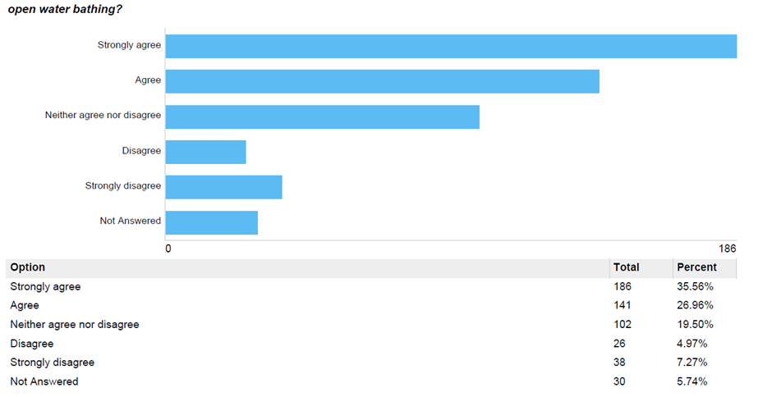

Graph 5: How strongly do you agree or disagree with the proposed byelaw 1 regarding the protection of structures and plants?
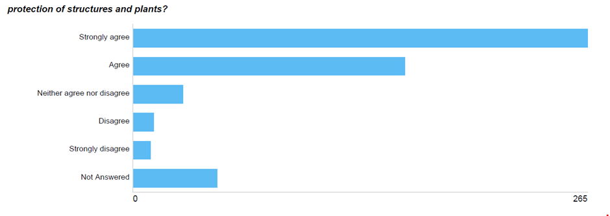

Graph 6: How strongly do you agree or disagree with the proposed byelaw 2 regarding the unauthorised erection of structures?
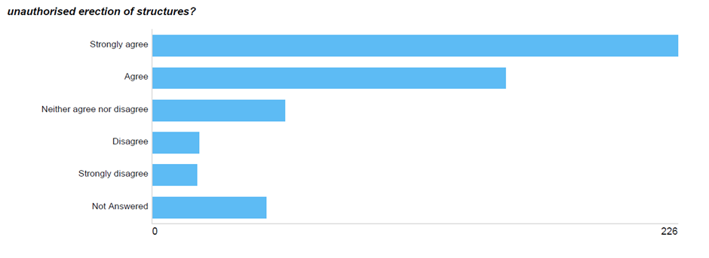
Graph 7: How strongly do you agree or disagree with the proposed byelaw 3 regarding grazing?
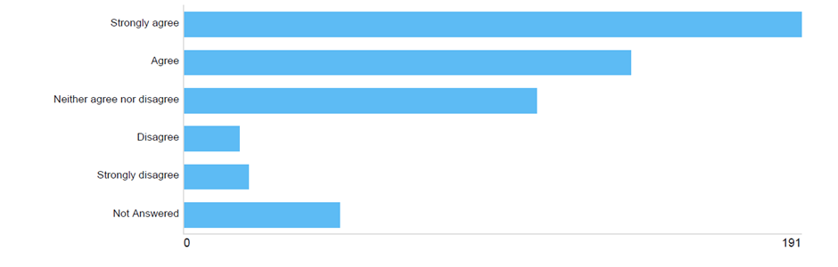

Graph 8: How strongly do you agree or disagree with the proposed byelaw 4 regarding protection of wildlife?
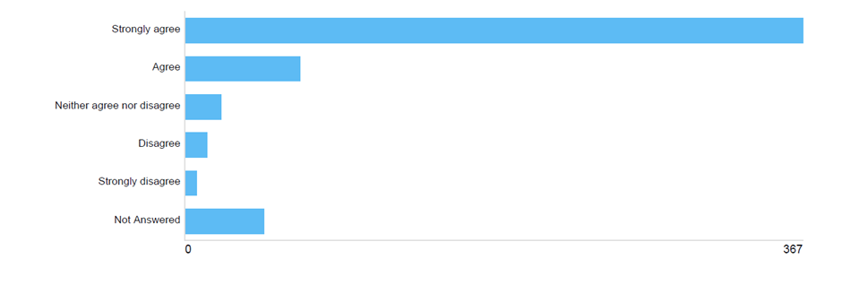

Graph 9: How strongly do you agree or disagree with the proposed byelaw 5 regarding camping?
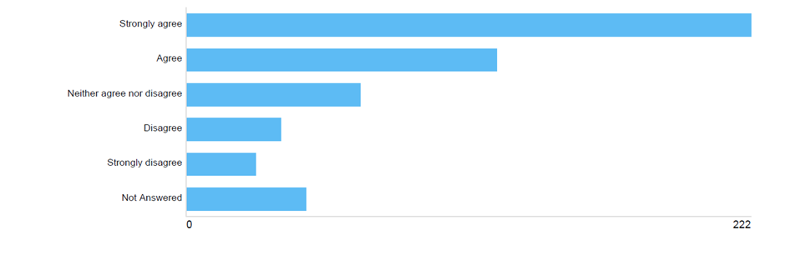

Graph 10: How strongly do you agree or disagree with the proposed byelaw 6 regarding fires?
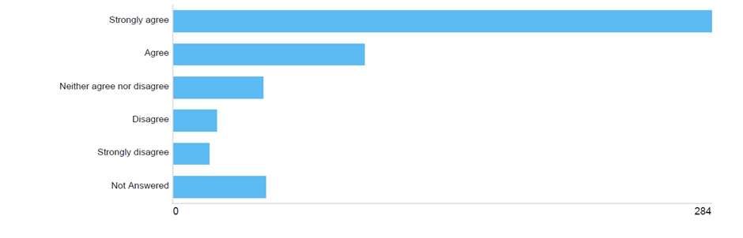

Graph 11: How strongly do you agree or disagree with the proposed byelaw 7 regarding missiles?
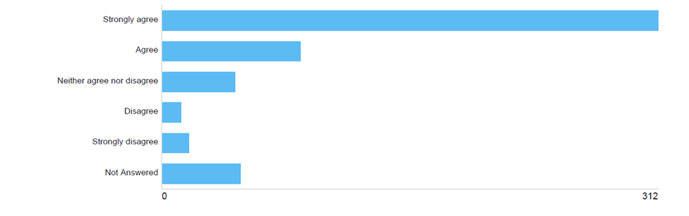

Graph 12: How strongly do you agree or disagree with the proposed byelaw 8 regarding interference with life-saving equipment?
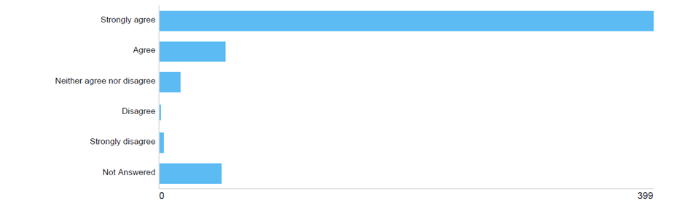

Graph 13: How strongly do you agree or disagree with the proposed byelaw 9 regarding horses?
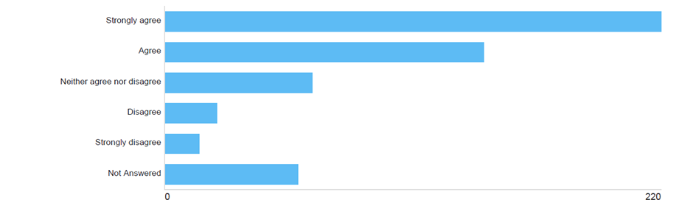

Graph 14: How strongly do you agree or disagree with the proposed byelaw 10 regarding cycling?
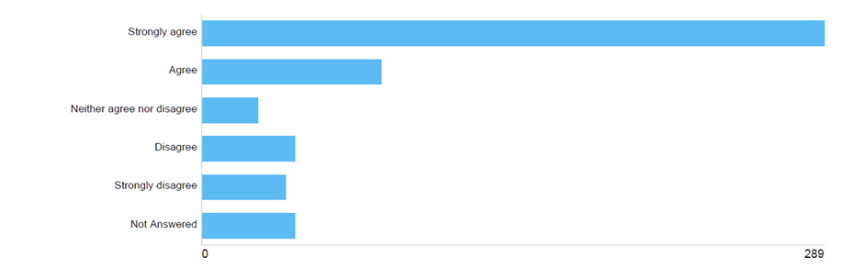

Graph 15: How strongly do you agree or disagree with the proposed byelaw 11 regarding motor vehicles?
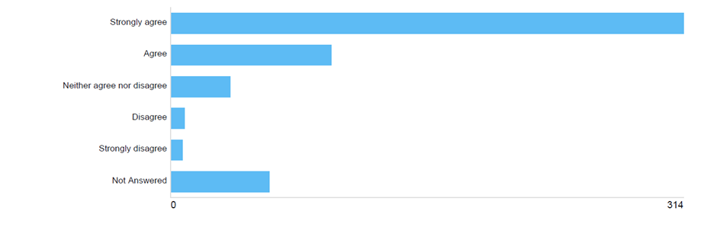

Graph 16: How strongly do you agree or disagree byelaw 12 regarding overnight parking?
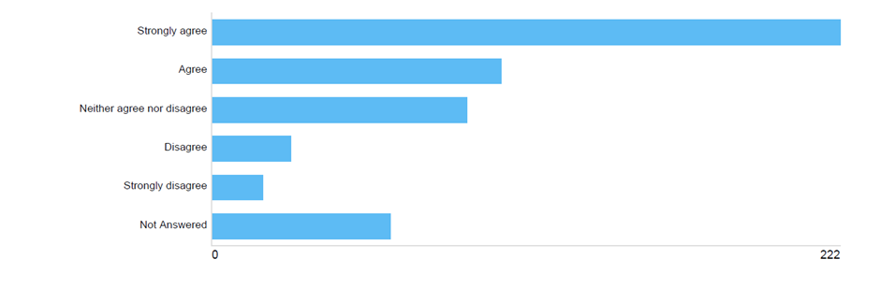

Graph 17: How strongly do you agree or disagree with the proposed byelaw 13 regarding children’s play areas?
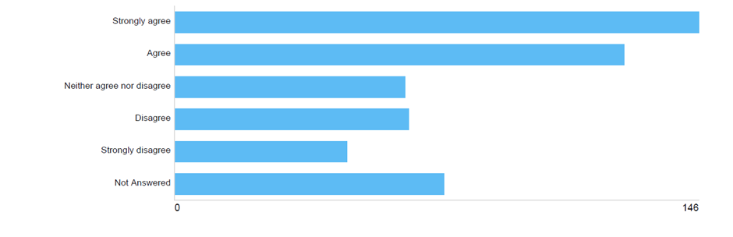

Graph 18: How strongly do you agree or disagree with the proposed byelaw 14 regarding children’s play apparatus?
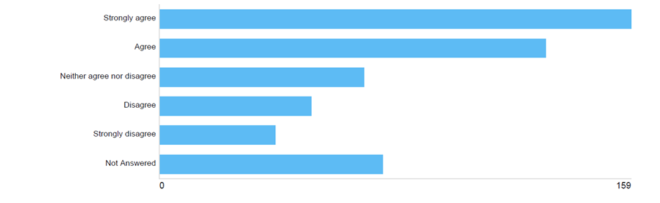
Graph 19: How strongly do you agree or disagree with the proposed byelaw 15 regarding skateboarding?
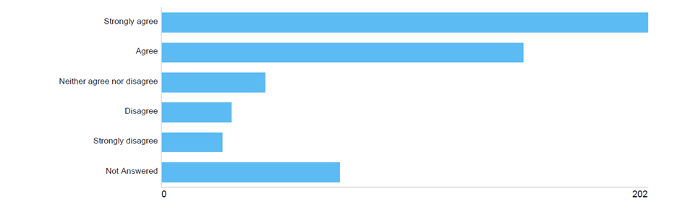

Graph 20: How strongly do you agree or disagree with the proposed byelaw 16 regarding cricket?
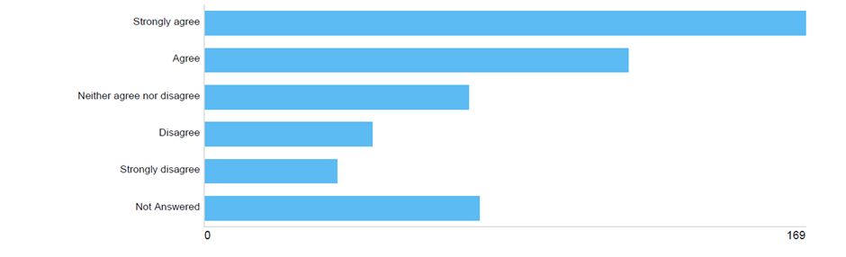

Graph 21: How strongly do you agree or disagree with the proposed byelaw 17 regarding archery?
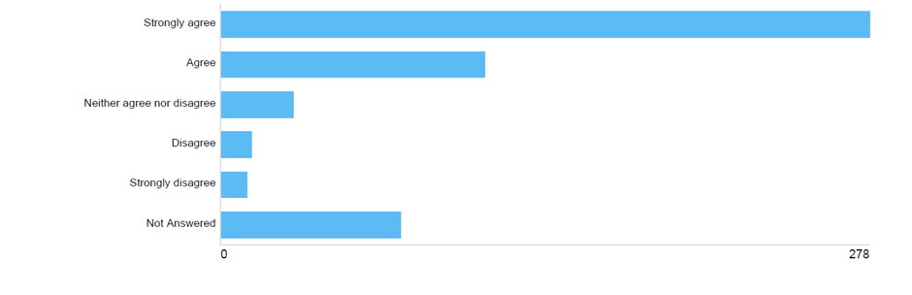

Graph 22: How strongly do you agree or disagree with the proposed byelaw 18 regarding field sports?
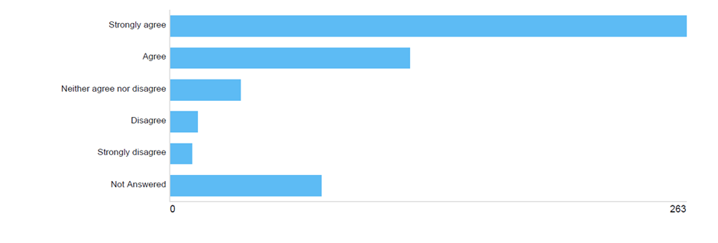
Graph 23: How strongly do you agree or disagree with the proposed byelaw 19 regarding golf?
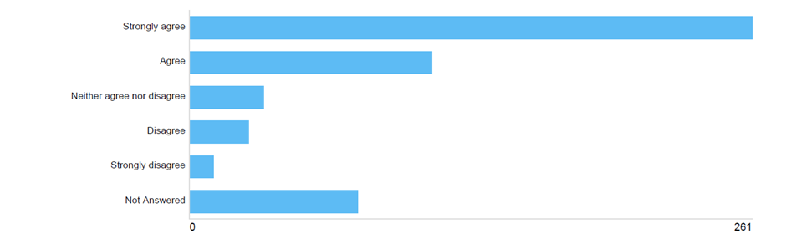

Graph 24: How strongly do you agree or disagree with the proposed byelaw 20 regarding golf where part of the ground is set aside as a golf course?
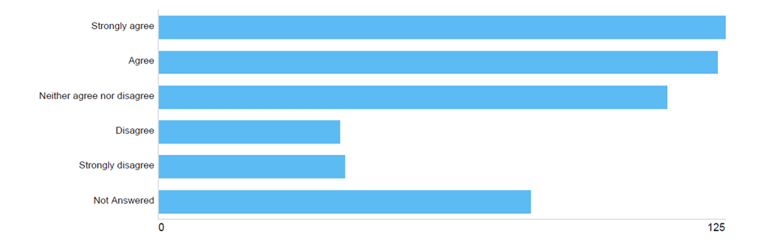

Graph 25: How strongly do you agree or disagree with the proposed byelaw 21 regarding mooring?
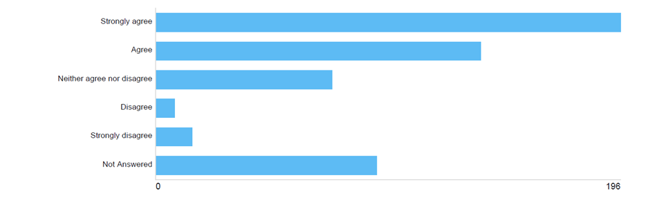

Graph 26: How strongly do you agree or disagree with the proposed byelaw 22 regarding fishing?
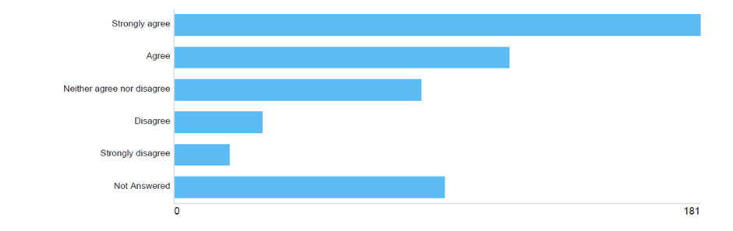

Graph 27: How strongly do you agree or disagree with the proposed byelaw 23 regarding blocking and pollution of watercourses?
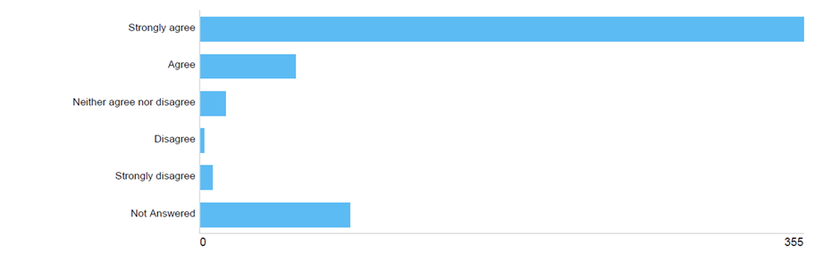

Graph 28: How strongly do you agree or disagree with the proposed byelaw 24 regarding model aircrafts and drones?
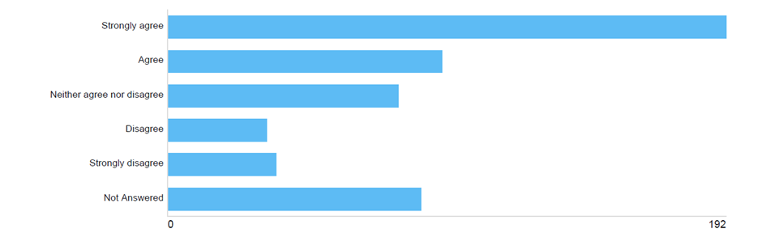

Graph 29: How strongly do you agree or disagree with the proposed byelaw 25 regarding e-scooters?
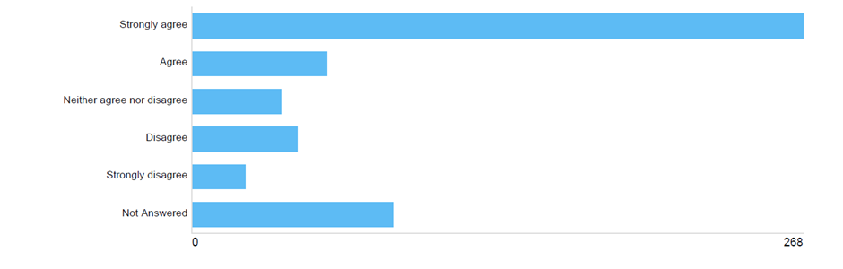

Graph 30: How strongly do you agree or disagree with the proposed byelaw 26 regarding provision of services?
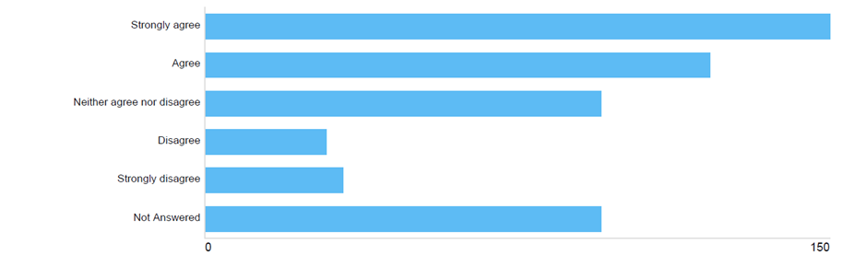

Graph 31: How strongly do you agree or disagree with the proposed byelaw 27 regarding excessive noise?
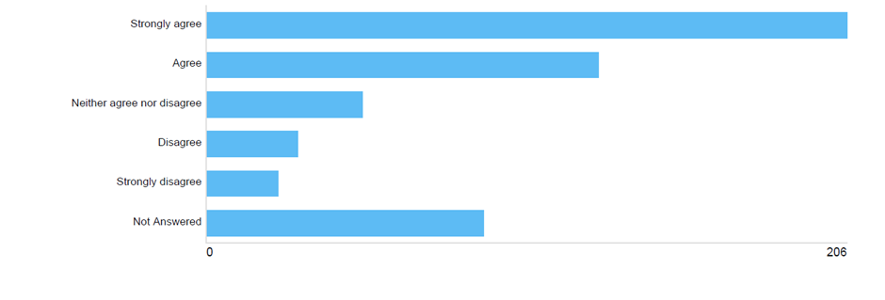
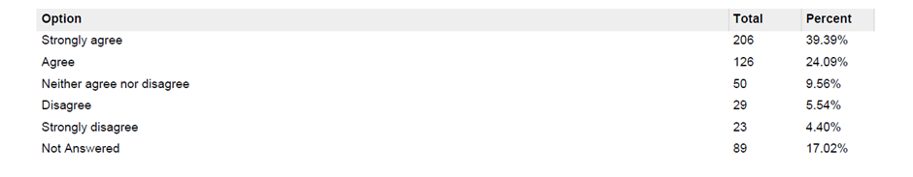

Graph 32: How strongly do you agree or disagree with the proposed byelaw 28 regarding public shows and performances?
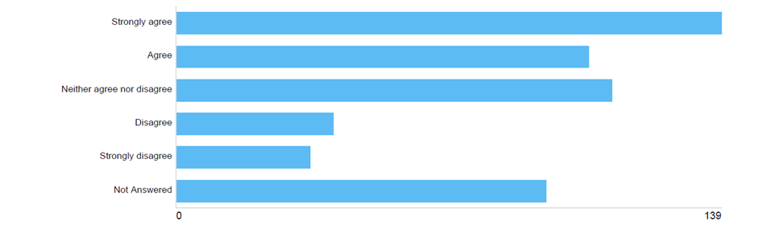
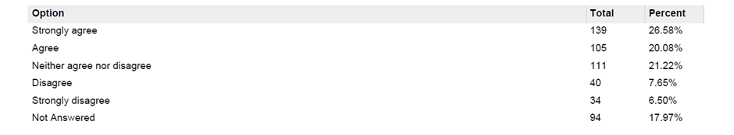

Graph 33: How strongly do you agree or disagree with the proposed byelaw 29 regarding aircraft, hang gliders and hot-air balloons?
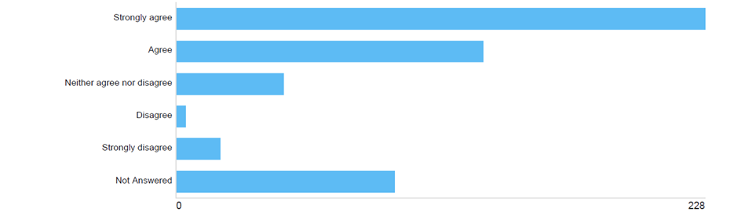

Graph 34: How strongly do you agree or disagree with the proposed byelaw 30 regarding metal detectors?
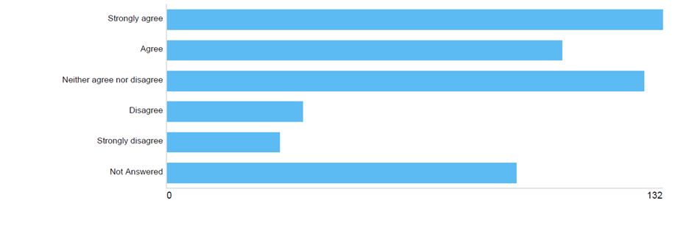
Graph 35: How strongly do you agree or disagree with the proposed byelaw 31 regarding obstruction?
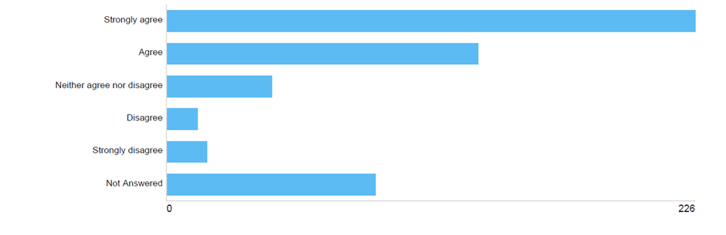
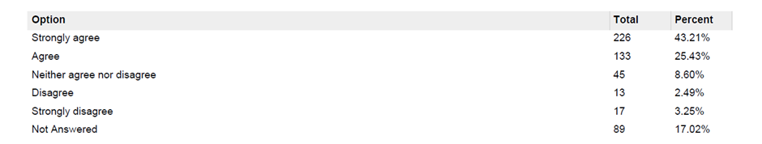

Graph 36: How strongly do you agree or disagree with the proposed byelaw 32 regarding savings?
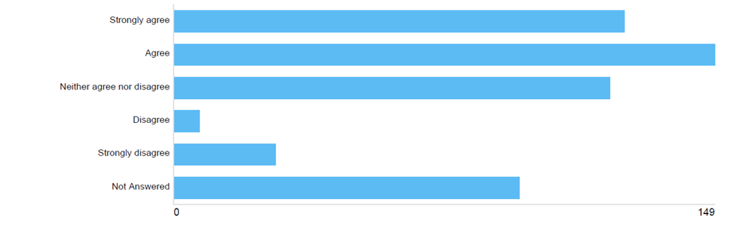
Graph 37: How strongly do you agree or disagree with the proposed byelaw 33 regarding removal of offenders?
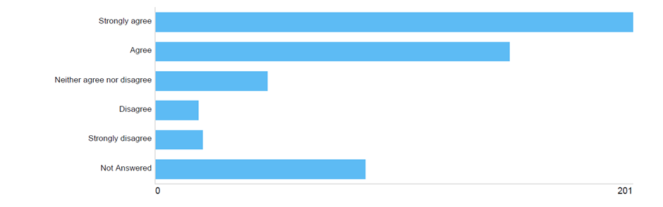

Graph 38: How strongly do you agree or disagree with the proposed byelaw 34 regarding penalty?
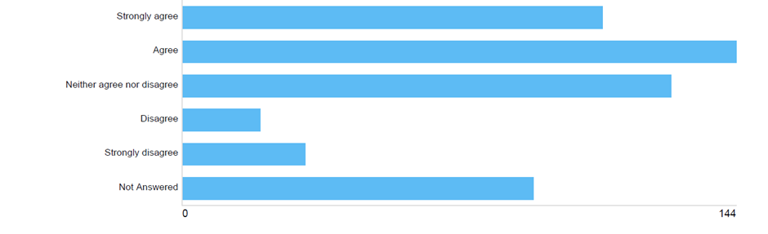
Graph 39: How strongly do you agree or disagree with the proposed byelaw 35 regarding revocation?
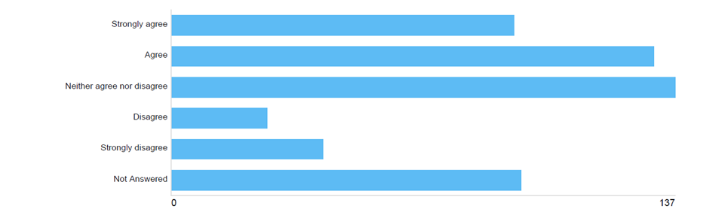

Graph 40: How strongly do you agree or disagree with the proposed byelaw 36 regarding revocation?
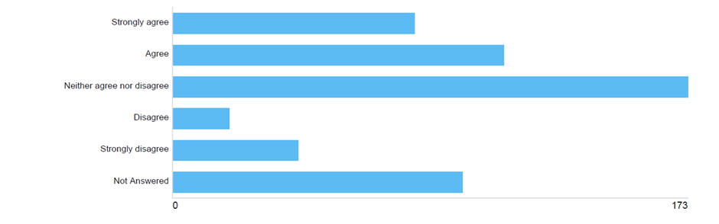

Appendix 2: Impact of the proposed byelaws on respondents

Graph 41: Are you impacted by the proposed byelaw 1 regarding the protection of structures and plants?
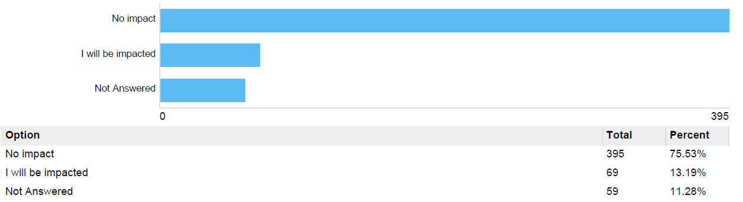

Graph 42: Are you impacted by the proposed byelaw 2 regarding the unauthorised erection of structures?
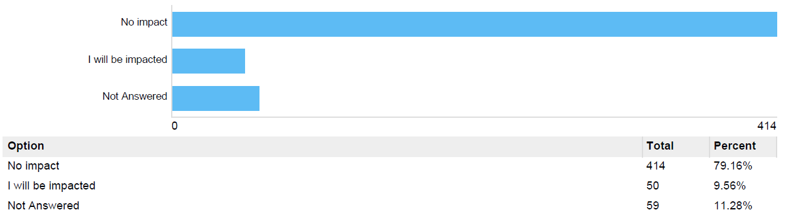

Graph 43: Are you impacted by the proposed byelaw 3 regarding grazing?
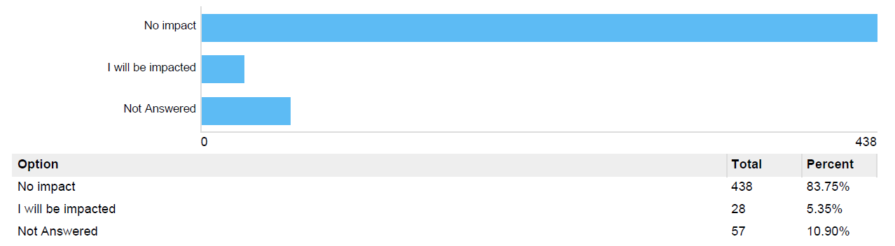
Graph 44: Are you impacted by the proposed byelaw 4 regarding protection of wildlife?
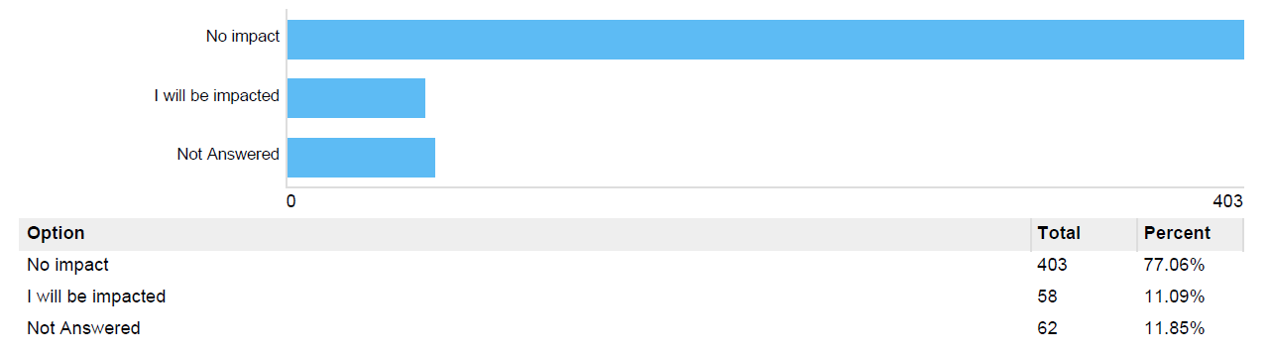

Graph 45: Are you impacted by the proposed byelaw 5 regarding camping?
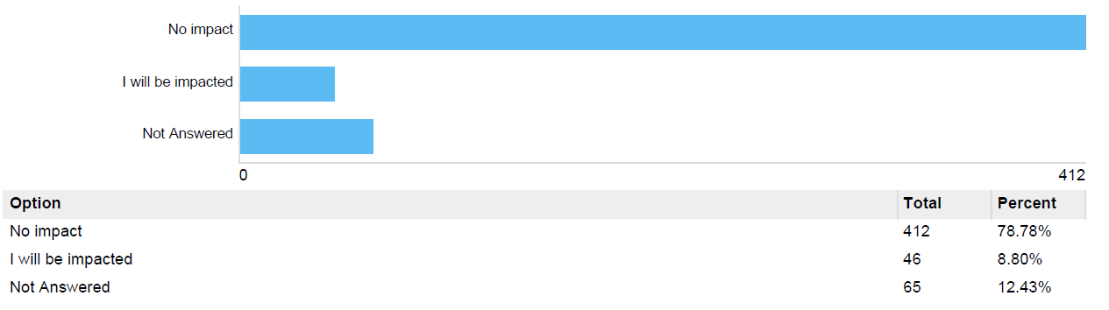

Graph 46: Are you impacted by the proposed byelaw 6 regarding fires?
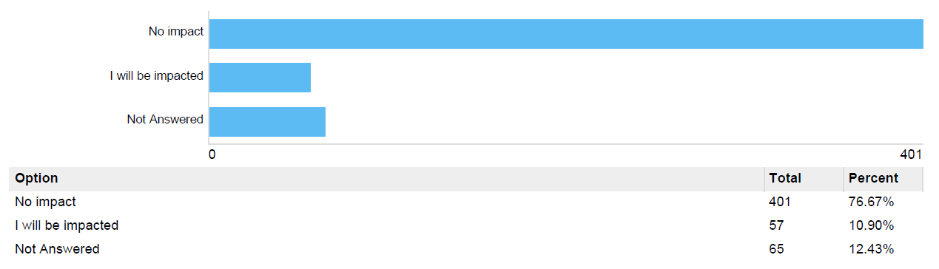

Graph 47: Are you impacted by the proposed byelaw 7 regarding missiles?
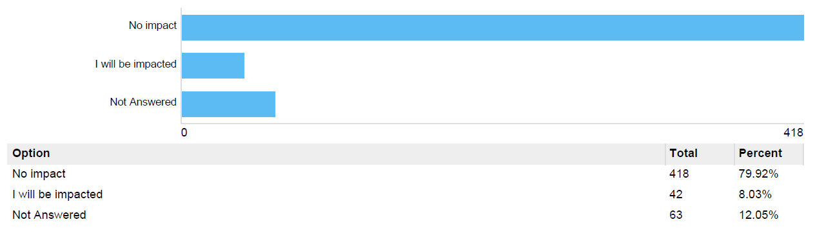

Graph 48: Are you impacted by the proposed byelaw 8 regarding interference with life-saving equipment?
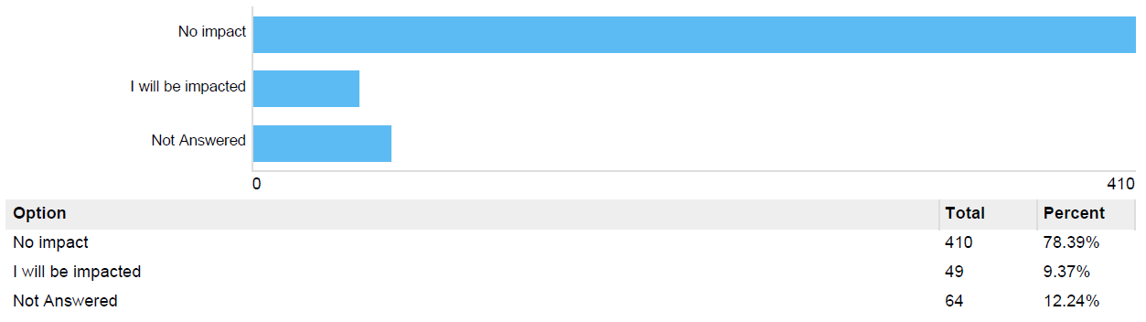

Graph 49: Are you impacted by the proposed byelaw 9 regarding horses?
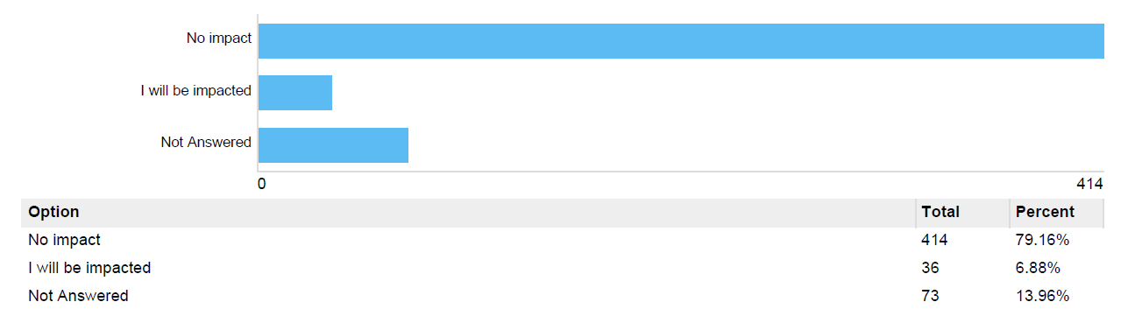

Graph 50: Are you impacted by the proposed byelaw 10 regarding cycling?

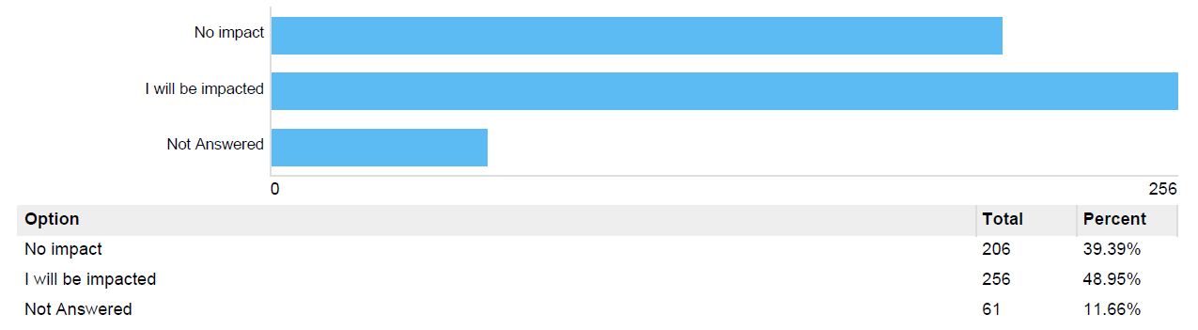

Graph 51: Are you impacted by the proposed byelaw 11 regarding motor vehicles?
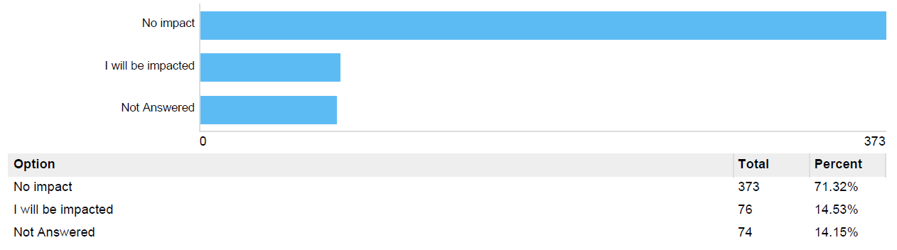

Graph 52: Are you impacted by the proposed byelaw 12 regarding overnight parking?
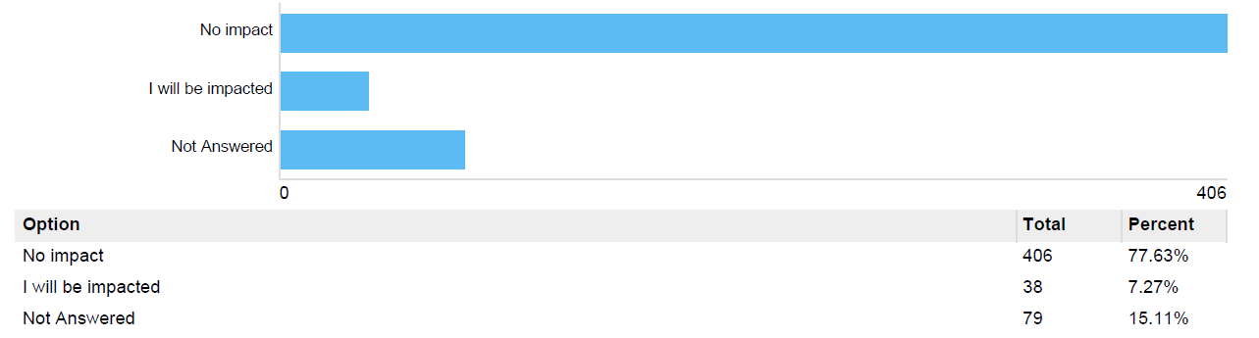

Graph 53: Are you impacted by the proposed byelaw 13 regarding children’s play areas?
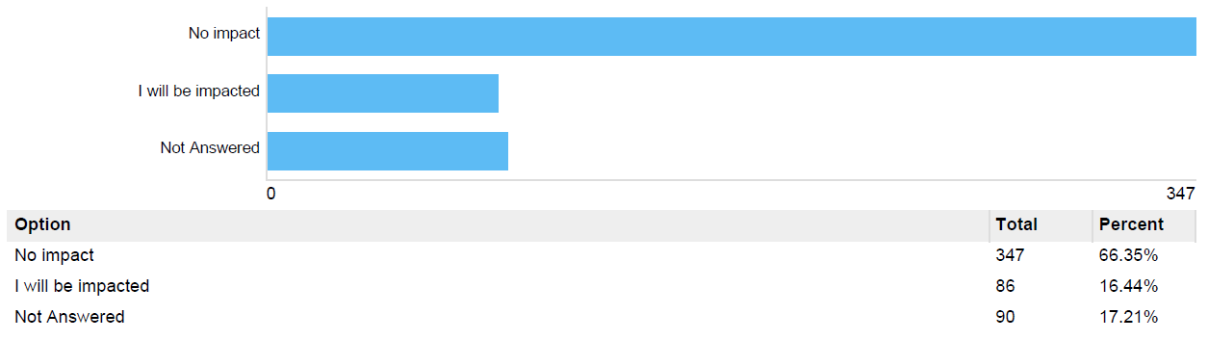

Graph 54: Are you impacted by the proposed byelaw 14 regarding children’s play apparatus?
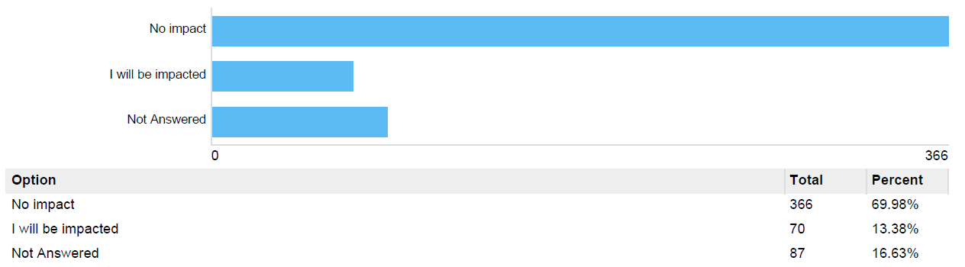

Graph 55: Are you impacted by the proposed byelaw 15 regarding skateboarding?
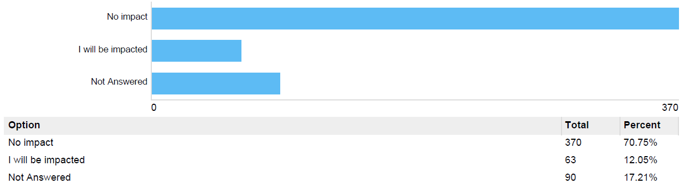

Graph 56: Are you impacted by the proposed byelaw 16 regarding cricket?
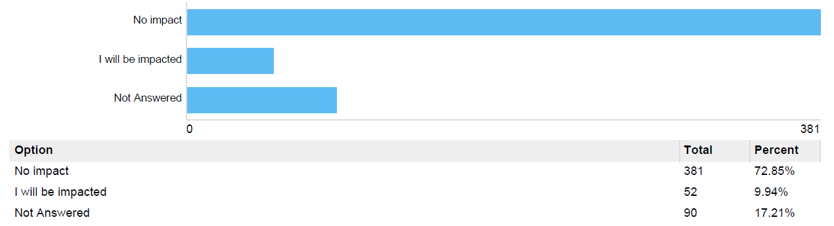

Graph 57: Are you impacted by the proposed byelaw 17 regarding archery?
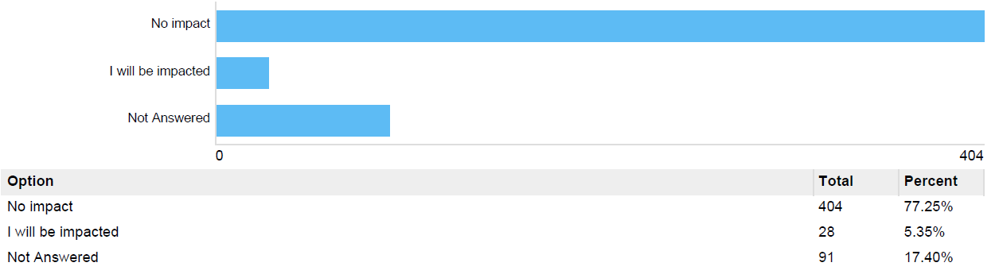

Graph 58: Are you impacted by the proposed byelaw 18 regarding field sports?
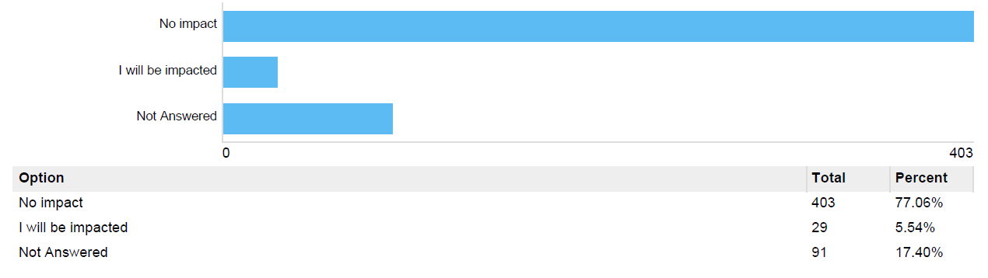

Graph 59: Are you impacted by the proposed byelaw 19 regarding golf?
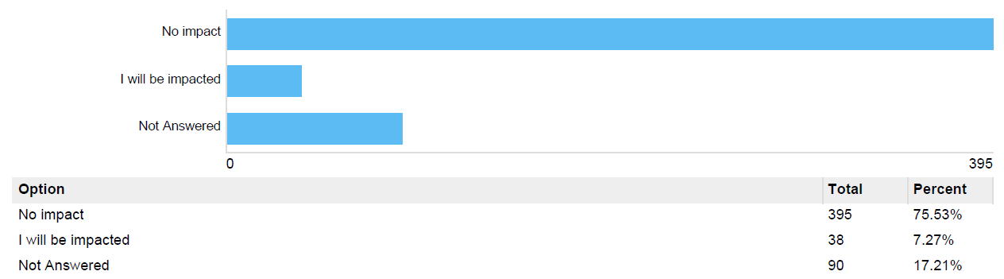
Graph 60: Are you impacted by the proposed byelaw 20 regarding golf where part of the ground is set aside as a golf course?
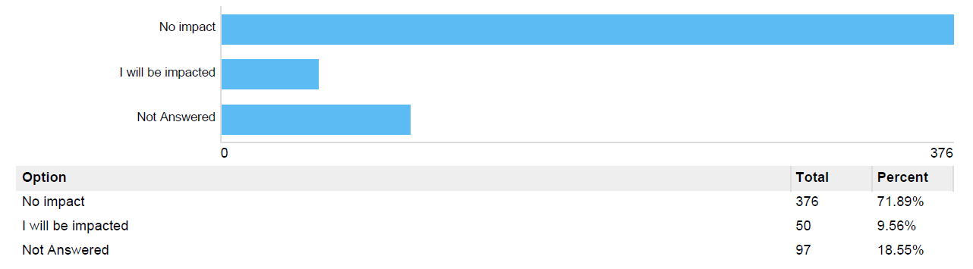

Graph 61: Are you impacted by the proposed byelaw 21 regarding mooring?
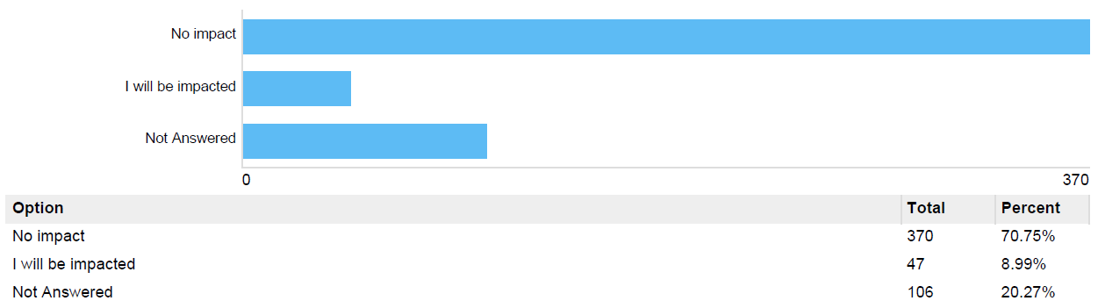

Graph 62: Are you impacted by the proposed byelaw 22 regarding fishing?
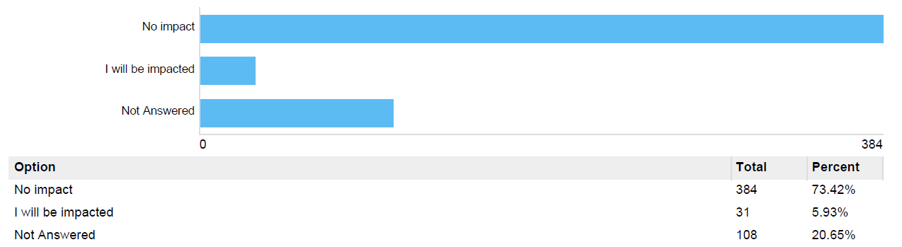

Graph 63: Are you impacted by the proposed byelaw 23 regarding blocking and pollution of watercourses?
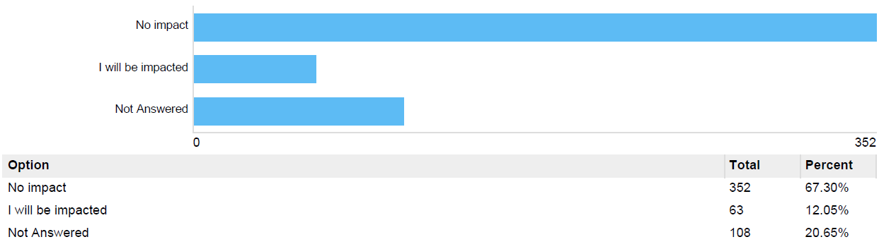

Graph 64: Are you impacted by the proposed byelaw 24 regarding model aircrafts and drones?
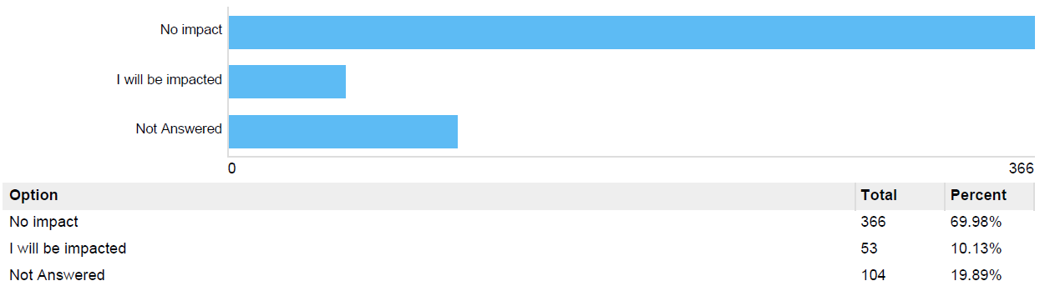

Graph 65: Are you impacted by the proposed byelaw 25 regarding e-scooters?
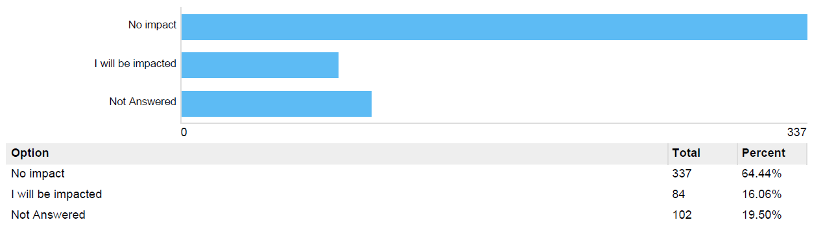

Graph 66: Are you impacted by the proposed byelaw 26 regarding provision of services?
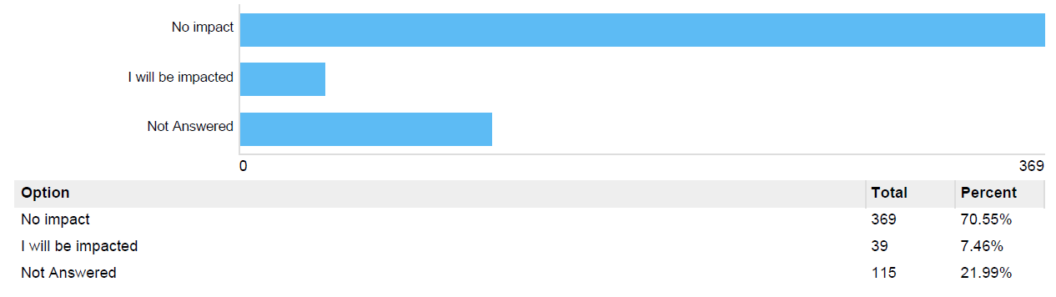

Graph 67: Are you impacted by the proposed byelaw 27 regarding excessive noise?
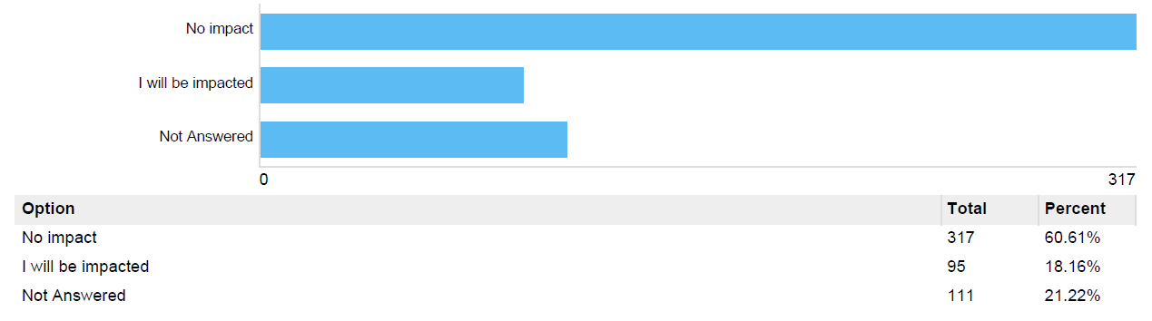

Graph 68: Are you impacted by the proposed byelaw 28 regarding public shows and performances?
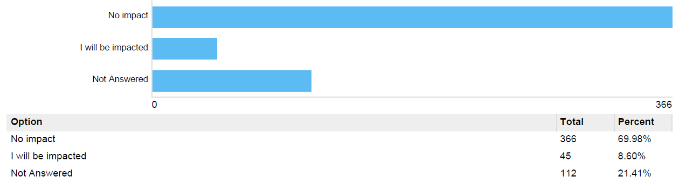

Graph 69: Are you impacted by the proposed byelaw 29 regarding aircraft, hang gliders and hot-air balloons?

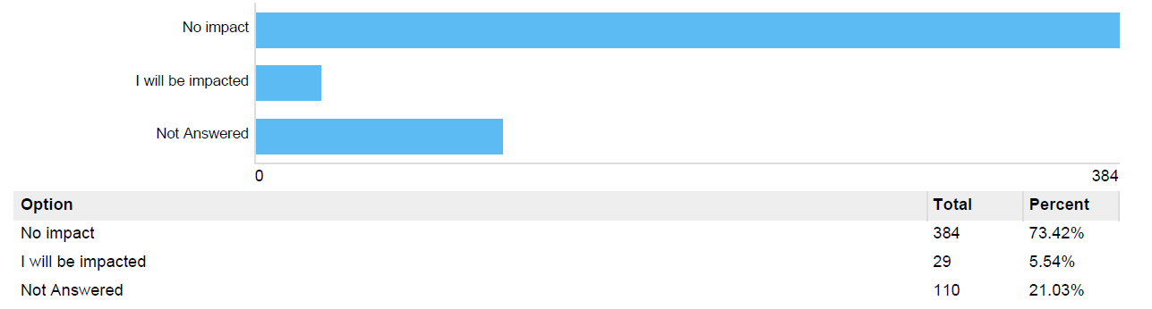

Graph 70: Are you impacted by the proposed byelaw 30 regarding metal detectors?
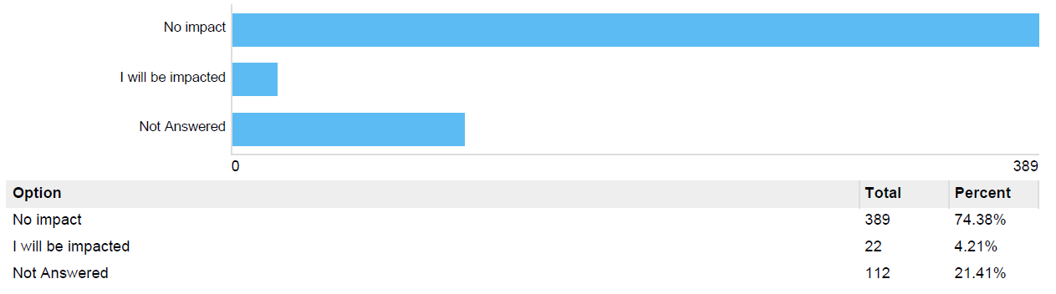

Graph 71: Are you impacted by the proposed byelaw 31 regarding obstruction?
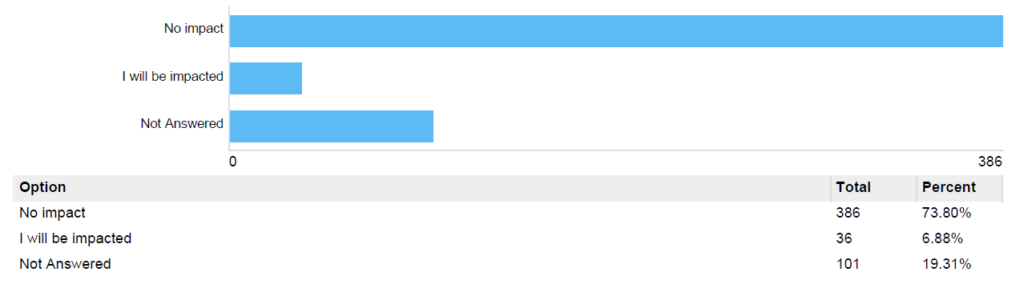

Graph 72: Are you impacted by the proposed byelaw 32 regarding savings?
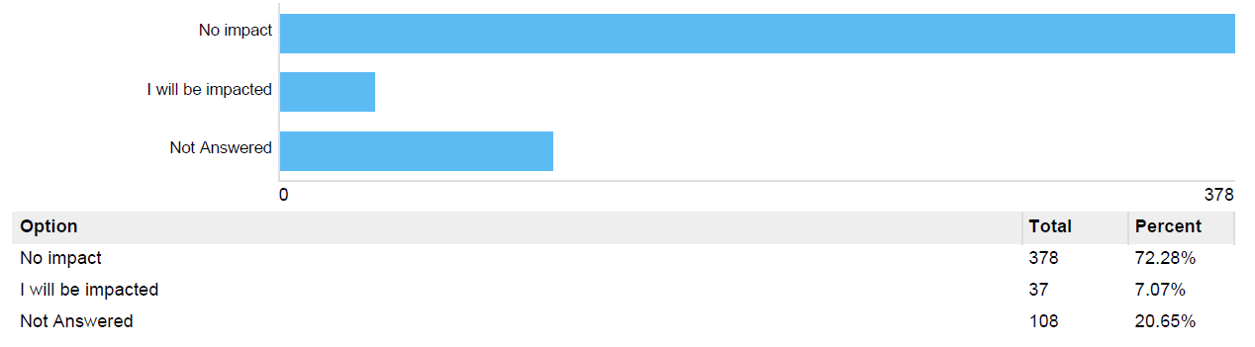

Graph 73: Are you impacted by the proposed byelaw 33 regarding removal of offenders?
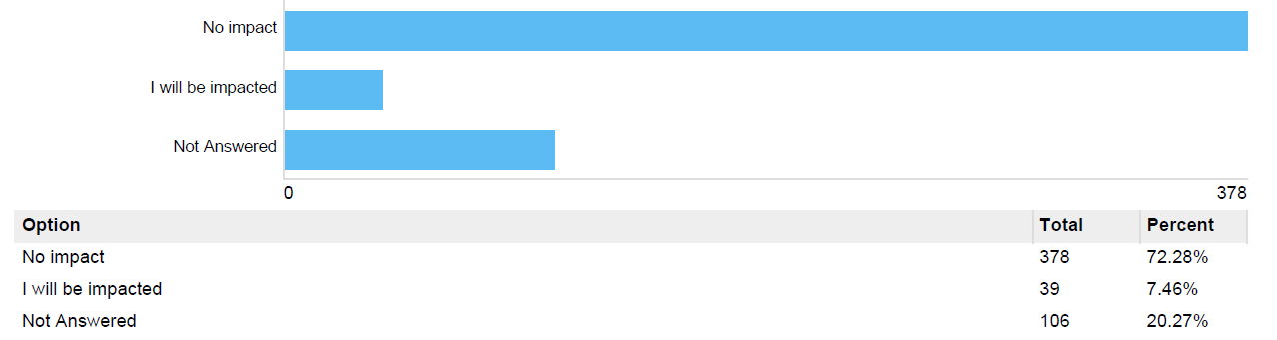

Graph 74: Are you impacted by the proposed byelaw 34 regarding penalty?
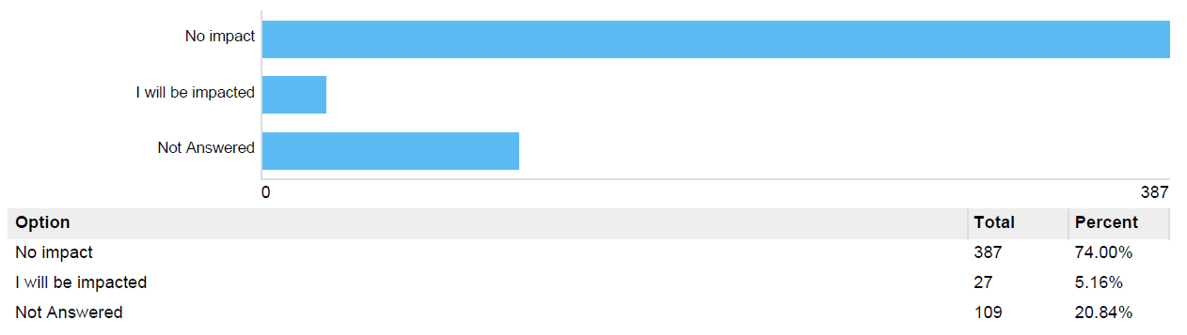

Graph 75: Are you impacted by the proposed byelaw 35 regarding revocation?
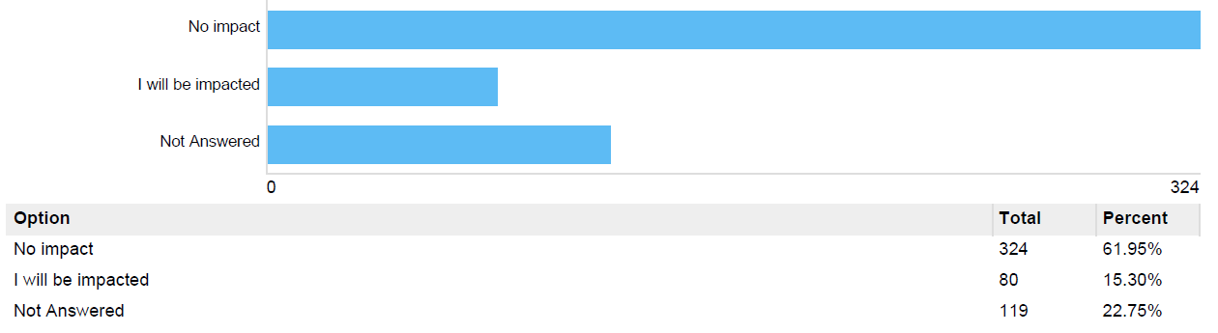

Graph 76: Are you impacted by the proposed byelaw 36 regarding revocation?
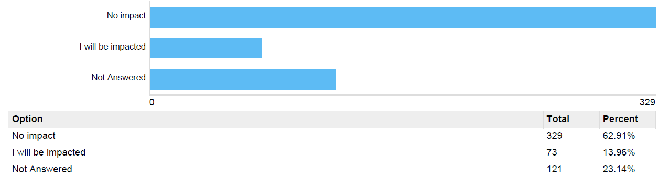

Appendix 3: Oxford City Council launches public consultation on proposed changes to parks and open spaces byelaws

Oxford City Council launches public consultation on proposed changes to parks and open spaces byelaws.
Published: Monday, 12 February 2024
Oxford residents and park users are being asked for their views on proposed changes to existing byelaws for the city’s 130 parks and open spaces.
Like most local authorities, Oxford City Council has a set of byelaws in place for its parks, nature areas and play facilities. These provide a basic set of rules around the use of these public spaces to ensure people behave in ways which respect the enjoyment, wellbeing and safety of others.
They also aim to ensure the protection of habitats, wildlife and the wider environment.
The Council has not amended its Parks and Open Spaces byelaws for over 25 years.
Changes to byelaws
The proposed changes include:
- revoking old byelaws relating to ball games, climbing and wild swimming – these are no longer relevant or appropriate, and go against the pressing need to encourage more active lifestyles
- amending byelaws to better reflect the way Oxford’s parks are used – for example, seeking public views on removing the blanket ban on cycling to allow considerate cycling in parks, as there are now cycle lanes through Cowley Marsh Recreation Ground and Donnington Playing Fields
- making new byelaws to deal with new challenges and changing priorities that have emerged over the last 25 years, like e-scooters and the use of drones and sky lanterns
The changes propose to consolidate the list of parks and open spaces currently covered to ensure consistency and simplicity across the city. For example, Shotover Country Park will be included under the main park byelaws, where previously it had a separate set.
The proposed new list will include new play spaces created since the byelaws were last updated. These include those installed as part of the expansion of Greater Leys and where older, poorly sited play areas have been replaced, like the one on the corner of The Slade and Girdlestone Road. It will remove other sites subject to change of land use.
Breaching byelaws
While byelaws can be enforced by council officers and the police, the Council’s main aim is to deal with breaches as informally as possible by talking to people in the first instance, or by issuing a notice requiring compliance.
If someone fails to take notice of advice given and continues to breach a byelaw, officers will take down details for use as evidence. Breaching a byelaw is an offence and someone deliberately doing so may be prosecuted.
Public consultation
The consultation is scheduled to run from Monday 12 February until Monday 8 April.
To ensure an in-depth and inclusive consultation process, the Council will engage directly with key community stakeholders, such as local park “Friends of”, groups, societies, and neighbourhood forums, to obtain their feedback on the proposals.
Oxford residents and park users can have their say on the proposals by visiting the Council’s consultation portal.
Comment
“At Oxford City Council, we want everyone to be able to enjoy Oxford’s parks and open spaces. To ensure that people can do this safely, we sometimes have to proactively tackle anti-social and nuisance behaviours that negatively impact users of our 130 green spaces. To help us do this, we have a set of byelaws – but it’s high time these were amended to reflect how our parks are enjoyed by everybody.
“The proposed changes are a long-overdue positive step towards creating a more accessible, pragmatic and sensible framework for users, to ensure a cleaner, safer environment within our city's green spaces.
“Most importantly, we are not doing this in isolation. We are committed to fostering a comprehensive consultative process with park stakeholders that captures the diverse perspectives across our community, ensuring their opinions contribute to shaping the future regulations governing Oxford's Parks and Open Spaces.”
Councillor Chewe Munkonge, Cabinet Member for Leisure and Parks

Appendix 4: Stakeholders contacted
Internal
- YourOxford (external newsletter)
- Council's social media platforms
- Connected Council (internal newsletter)
- Youth Ambition
- Events Team
- Locality managers
- Equality, Diversity and Inclusion Lead
- Residents Panel
Stakeholders by park
Blackbird Leys Park
- Blackbird Leys and Greater Leys Neighbourhood Watch
- Oxford Blackbirds Football Club
- Blackbird Leys Park Bowls Club
- Activate Learning (Oxford & Cherwell Valley College)
Botley Park
- Bowls Club
- Low Carbon West Oxford
- West Oxford Community Centre
Bury Knowle Park
- The Friends’ Group
- The library staff and users
- Health walks organiser
- Premier Tennis
- Courtside (sports hub)
- Headington Fun Day
Cutteslowe and Sunnymead Park
- Summertown Starts FC
- Wolvercote CC
- The Friends’ Group
- The Allotment Association
- City of Oxford Society of Model Engineers Club (COSME)
- External contractor for the kiosk (San Remo)
- The residents of the farm house and cottages within the park
- ParkRun
- Green Houses
Florence Park
- Friends of Florence Park
- Flo’s The Place in the Park
- Woofers of Florence Park
- Annie's new group who are managing Kate's Place
- Flofest
- Trapeze school
Hinksey Park
- Hinksey Sculling School
- Oxford BSAC Scuba & Snorkel Diving Club based in the pool facility
- Spragglesea Mead & Dean Ham Allotment Association
- Oxford Model Boat Club
- Oxford Model Boat Club
- Lake Street Play Group whose nursery is in the pool facility
- South Oxford Community Centre
- Local children’s football teams
Port Meadow
- Freemen of Oxford
- Berks Bucks and Oxon Wildlife Trust
- Oxford and District Anglers Association
- Oxford Preservation Trust
- Port Meadow Protection Group
- Friends of Burgess Field
- Friends of the Trap Grounds
- Medley Sailing Club
- North Oxford Association
- St Edward’s School
- St Barnabas School
Shotover Park
- Shotover Wildlife Group
- Shotover Preservation Society
South Park
- Friends of South Park
- Oxford Preservation Trust
- Oxford Brookes University
- EF College
- Foodies Festival
- Round Table
- Be Military Fit
Groups with protected characteristics
Disability
- MyVision Oxfordshire
- Oxfordshire Learning Disabilities Community
- OXSRAD (Disability Hub & Sport Facility)
- ADHD Oxfordshire
- Autism Champions
- Carers Oxfordshire
- Down's Syndrome Oxford
- Oxfordshire Dyslexia Association
- My Life My Choice
- Disability Advisory Service - University of Oxford
Race
- Anti-racism charter signatures
- Community Champions
Religion or belief
- Interfaith leaders
Other user groups
Cyclists
- CyclOx
- Active Oxfordshire
- Brookes University Cyclist Forum
- Oxford University Cycling Club
- JoyRiders
- Botley Bikers
- CyclAbility (previously Wheels for All Oxford)
Sports groups
- Norham Gardens Tennis Club
- Oxford Harlequins Rugby Club
- Oxford City Athletics Club
- Oxford United FC
- Premier Tennis (now Courtside)
- North Oxford Tennis Club
- Oxford Hawks Hockey Club
- 600 users on Pitchbookings
Waterways stakeholders
- River User Groups
- Environment Agency Waterways team
- Falcon Rowing Club
Other green spaces stakeholders
- Alexandra Park Friends Group
- Angel and Greyhound / Christ Church College
- Barton Bradley football teams
- Barton community Centre
- BBOWT
- Boundary Brook - lease holder group
- Court Place Farm football teams
- IFRA for Donnington and Meadow Lane
- Friends of Headington Hill Park
- Horspath sports grounds, north and south - lease holders
- Manzil Way - Restore cafe
- Margaret Rd Rec football teams
- Oatlands Rec - County Council
- North Oxford association
- Peat Moors - Bullingdon Community Centre
- Lye Valley Friends Group
- Trap grounds - Friends group
Parish councils
- Blackbird Leys
- Littlemore
- Old Marston
- Risinghurst and Sandhills

Appendix 5: Sample comments relating to the main areas of concern and topics for suggested amendments
Sample comments requesting the retention of a prohibition of cycling in Hinksey Park (other than use of the designated cycle path through the outer park), and at the Trap Grounds and Lye Valley Wetland Nature Areas
- “I support certain aspects of the change to the by laws but it is important that families especially with young children have a safe environment to play. Cyclists in hinksey park already have a dedicated cycle path and as a local resident in the area I have watched over the last decade so many near misses with young children and the elderly where cyclists have cycled through the park and nearly knocked people. A change in law would not be able to be policed and catch offenders so please consider if this is changed you are going to make it very unsafe for the majority who use the park”
- “I support the general thrust, but more thought needs to be given to where cycling is permitted. One of my local parks, Hinksey Park, has a cycle lane through it, and so clearly cycling should be permitted here(!) but equally it would be inappropriate to open up the fenced off area of the park (around the boating lake and by the swimming pool) to cyclists, as this is likely to result in cyclists taking a slight short cut through this area of the park (rather than following the cycle path) and mowing down children and animals (this is already a problem even though at present cycling is not permitted in this part of the park)”.
- “As a regular cyclist I am more than happy to use the cycle path that goes around Hinksey park. It is completely unnecessary to have the rest of the park open to cycling. The path around the boating lake gets very busy with, toddlers, buggies, elderly people, particularly in the summer. Accidents would be inevitable if it opens to cyclists. Please leave it as it is as regards Hinksey Park”
- “I don't support cycling in Hinksey Park (though people already do). It's too small, and there's a cycle path round the outside, so it isn't necessary to cycle through the park itself. Parks provide a safe space for pedestrians. Cycles are vehicles and already there is conflict when a minority of cyclists think they have right of way on footpaths. I myself, as an elderly person, have been shouted at to make way for speeding cyclists on footpaths. Recently this happened when I was on two crutches.”
- “It is absolutely not safe for children to allow cycling in hinksey park around boat lake. Even ‘considerate’ cycling. There are many blind spots on the way round and it’s unfair to change this into a family-unfriendly area. Allowing cyclists would cause distress and accidents. Save yourself the hassle and don’t allow cyclists through this area at all. You will be inundated with complaints and just need to change it back again”
- “In the case of the Trap Grounds nature reserve, the current ban on cycling serves an important purpose. It means that the wildlife on the small site is much less likely to be disturbed and frightened. In general, of course, it's good to have more cycling so this comment is specific to the Trap Grounds”
- “I think that cycling in municipal parks, on wide, hard-surfaced tracks, might be OK, but I strongly disagree with the proposal to revoke the ban if it would affect sensitive wildlife sites. The Trap Grounds Local Wildlife Site has no such cycle-suitable tracks. The main route through the site is a stream-side boardwalk which has cost the local community £25,000 to install and maintain. It could not bear the weight of frequent cycle rides and would soon start to sink into the swamp surrounding it”
- “I strongly support considerate cycling on suitable paths - for example, across Florence Park from Florence Park Road to the end of Campbell Road.
However, cycling should not be permitted in nature reserves like Lye Valley or
across green spaces, where it can damage the soil structure and vegetation”

Sample comments regarding use of play areas by teenagers
- “15-17 year olds are still children. Frankly, this measure encourages teenagers to seek out more dangerous sources of entertainment instead of allowing them to have fun in a safe environment. It also encourages them to hang out in more dangerous spaces such as near pubs or other public places where there may be adults drinking which puts them in danger”
- “Some play areas are unfenced anyway eg in Florence Park - is the intention to prevent teenagers enjoying themselves, keeping healthy, being outdoors, etc?
Where schools travel routes involve open spaces and parks this could also be difficult eg Spires/Cowley Marsh. And sibling groups? I know some teenagers can be a pain at times but a blanket ban seems well over the top.”
- “My child is over 14 and disabled. He still enjoys playing in the play park - is he not welcome? That seems very sad and narrow minded.”
- “Swings are great for adults! And teenagers, especially girls as it gives them a place to sit and hang out. If they can’t go into play areas, please can we have adult swings?”
- “I think that this byelaw needs much better wording - when my small nephew comes, we may go to a children's play area and there will be more than one adult in the group - we can't all be in charge of one child! The current wording implies only one person over 14 per child under 14. What about older teenagers who have additional needs?”
- “Most youth clubs have shut down. Parks are important to the social life of older teenagers”
- “How will this be policed?”
- “I think it's extreme. Some teenagers grow up more slowly than others. I wouldn't want to tell them they can't use the swings. Also they could be part of a family group, while still not in charge of the younger children”
- “This could make family activity in play areas difficult”
- “I do not think a byelaw for this is necessary at all. This could technically incriminate families visiting such areas where there is an older sibling (aged 14 or over) present, and I think this sends the wrong message. Even if this were to tackle antisocial teenagers, I think there are likely better ways to go about this”.
- “Among other problems, this would make it impossible for the council to create play areas designed for teenagers. This is also unenforceable as 11-13 year olds are unlikely to have documentation proving they are under 14 - and will in practice be discriminatory against taller children.”
Sample comments requesting specific reference to barbeques in the byelaw (6) relating to fires
- “Byelaw 6 on Fires is welcome but should explicitly mention barbecues, for the avoidance of arguments/doubt”
- “Portable barbecues should be restricted and potentially even prohibited as these often leave detritus behind and can and have caused small fires”
- “FoCSP suggest the addition of:
(d) use or light a barbecue including disposable barbecues
(e) the lighting of fireworks”
- “Does this include electric or any other barbeques? If not, then it should be amended to make it absolutely clear that BBQ's are not permitted”
- “Can you also ban disposable or any other form of mobile BBQ”
Sample comments in support of the proposal to revoke the existing byelaws relating to tree climbing and ball games
- “We need to encourage as much activity outside in fresh air and open space as possible to promote health and wellness amongst all age groups and make it open to all city residents”
- “Access to parks for ball games for young people is essential in todays world where many families do not have large gardens”
- “Youth consultation in Oxfordshire shows time and again that climbing is the activity with the greatest unmet need especially for girls who typically face greatest barriers to physical activity. Incidental play and exercise is also vital for socialising, health and wellbeing and no ball games signs run completely counter to this”
- “It always seems extremely mean when there are ‘no ball games’ sign over a public place. We have a childhood obsession and screen epidemic, we don’t need to put them off with aggressive signs. We want children to play outside, climb things and be children.
- “Studies have shown almost no damage to trees from kids climbing them, so it would be great to have this. Also more people playing ball games makes everyone safer by having more people present to deter crime”

Sample comments in support of revoking the byelaws relating to wild swimming
- “Given that I didn’t even know this existed, and bathe in open water regularly, I would say it is a genuinely pointless byelaw! People who swim in rivers and lakes tend to do so very carefully and with friends or are experienced. There should be signs at fast flowing points or something about the flow after heavy rain but dedicated swimmers know this. Otherwise it should be encouraged and people’s enjoyment of our beautiful green and blue city should be something we take pride in. Swimming in the river and Hinksey lake is one of the reasons I love loving in Oxford”.
- “It is appropriate to warn but not legislate”.
- “There should be clear warnings in place, but risk should reside with individuals”
- “Other than reiterating the word on caution and not sending a confusing message lifting the ban while still discouraging those activities, I agree with this”

